Exploration with Datalab:

Visualization with Data Studio:

* What is Business Intelligence:

Is a set of methodologies, processes, architectures and technologies that transform raw data into meaningful and useful information.

* There are 3 essential areas to BI:
* **Reporting** – providing meaningful data & information in a way it can be used to formulate strategy.
* **Analytics** – Quantification of business processes in order to facilitate improvements and optimizations;
  + Many different skills are involved including
    - Data Mining, Statistical Analysis, Predictive Analysis, Business Process Modelling as well as Prescriptive Analysis.
* **Dashboards** – High level performance key indicators and benchmarks are used to measure progress towards business goals.

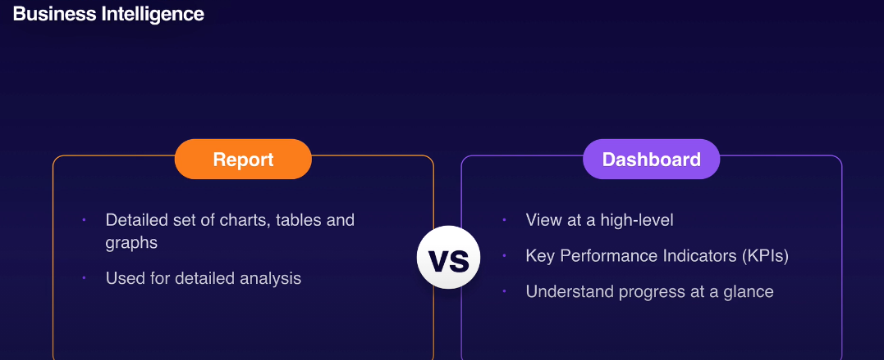

**Data Distributions:**

* The way your data is structured.
* **Discrete Variables:**
  + Can only take on specific fixed values. For example, rolling a die only returns values in the set {1,2,3,4,5,6}.
  + The die variable cannot return values between these values e.g. 2.5
  + Distribution of discrete variables normally take the form of a discontinuous graph.
* **Continuous Variables:**
  + Can take on any value within a specified range. E.g. the temperature can take on an intermediate value between two-degree e.g. 21.3 degrees C
  + Continuous distribution consist of smooth lines.
  + Every point of the X-axis has a corresponding value on the Y-axis.
* Common Distributions:

